

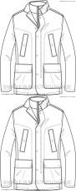
1.193
€ 221,46
€ 264.197,00

IMAGE | ARTICLE CODE | COLOR CODE | COLOR | SEA | GENDER | CATEGORY | MADE IN | COMPOSITION | 38 | 40 | 42 | 44 | 46 | 48 | 50 | 52 | 54 | 56 | 58 | 60 | TOT QTY | RRP |  | TOT RRP
 | M84P0AT2422 | F4300 | DARK NAVY | FW | MAN | JACKET | CN | 100%PA |  |  |  |  |  | 11 | 26 | 6 | 17 |  |  |  | 60 | € | 199,00 | € | 11.940,00
 | M84P0AT2422 | F9000 | BLACK | FW | MAN | JACKET | CN | 100%PA |  |  |  |  |  | 7 | 10 |  | 10 | 8 | 9 |  | 44 | € | 199,00 | € | 8.756,00
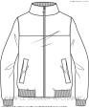 | M84P0CT0351 | F4300 | DARK NAVY | FW | MAN | JACKET | CN | 100%PL |  |  |  |  |  | 11 | 12 |  | 2 |  | 6 | 4 | 35 | € | 149,00 | € | 5.215,00
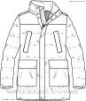 | M84P8BT2422 | F9000 | BLACK | FW | MAN | JACKET | ID | 100%PA |  |  |  |  |  | 5 | 7 | 10 | 1 |  | 3 | 3 | 29 | € | 239,00 | € | 6.931,00
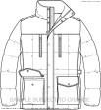 | M84P8QT2422 | F9000 | BLACK | FW | MAN | JACKET | ID | 100%PA |  |  |  |  |  |  | 10 |  |  |  |  |  | 10 | € | 219,00 | € | 2.190,00
 | M9221BT2552 | F4386 | BLUE NIGHTS | SS | MAN | JACKET | ID | 100%PL |  |  |  |  |  | 4 |  | 3 | 2 | 25 | 32 | 2 | 68 | € | 199,00 | € | 13.532,00
 | W0415DT2663 | F9000 | BLACK | FW | WOMAN | JACKET | CN | 100%PL | 5 | 1 | 20 | 12 | 6 | 3 |  | 2 |  |  |  |  | 49 | € | 319,00 | € | 15.631,00
 | W7220HT0434 | F4300 | DARK NAVY | SS | WOMAN | JACKET | CN | 86%PL 14%PA |  | 8 | 15 | 21 | 5 | 3 | 1 |  |  |  |  |  | 53 | € | 189,00 | € | 10.017,00
 | W7220HT0434 | F5079 | COBBLESTONE BEIGE | SS | WOMAN | JACKET | CN | 86%PL 14%PA |  | 4 | 13 | 16 | 15 | 10 | 10 | 4 |  |  |  |  | 72 | € | 189,00 | € | 13.608,00
 | W8220QT2415 | F7164 | BRIGHT SALMON | SS | WOMAN | JACKET | VN | 100%PL |  | 3 | 10 | 13 | 8 | 11 | 8 | 1 |  |  |  |  | 54 | € | 199,00 | € | 10.746,00
 | W8220XT2447 | F7162 | CRIMSON RED | SS | WOMAN | JACKET | VN | 100%PL | 4 | 3 | 7 | 10 | 4 | 9 | 7 | 1 |  |  |  |  | 45 | € | 159,00 | € | 7.155,00
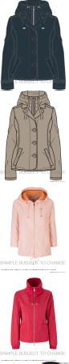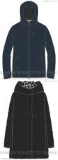

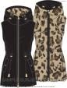 | W9420LTC130 | F9075 | BLACK/LT TAUPE ANIMA | FW | WOMAN | JACKET | CN | 100%PL / 100%PL |  | 12 | 12 |  | 4 | 6 |  |  |  |  |  |  | 34 | € | 199,00 | € | 6.766,00
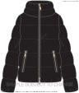 | W9428YT2568 | F9000 | BLACK | FW | WOMAN | JACKET | VN | 94%PL 6%EA |  | 5 | 18 | 10 | 10 | 3 |  |  |  |  |  |  | 46 | € | 229,00 | € | 10.534,00
 | M0428FT2451 | F4386 | BLUE NIGHTS | FW | MAN | JACKET | CN | 100%PL |  |  |  |  | 1 | 17 | 12 | 12 | 9 | 4 | 6 |  | 61 | € | 299,00 | € | 18.239,00
 | W0425YT2655 | F1479 | CLOUDY GREY | FW | WOMAN | JACKET | CN | 100%PL |  |  | 12 | 24 | 10 | 6 |  |  |  |  |  |  | 52 | € | 329,00 | € | 17.108,00
 | W0425ET2566 | F1571 | DARK CLOUDY GREY | FW | WOMAN | JACKET | CN | 100%PA |  |  | 20 | 10 | 10 |  | 2 |  |  |  |  |  | 42 | € | 239,00 | € | 10.038,00
 | W0428QT2656 | F4386 | BLUE NIGHTS | FW | WOMAN | JACKET | VN | 100%PA |  |  |  | 10 | 7 | 6 | 6 | 1 |  |  |  |  | 30 | € | 319,00 | € | 9.570,00
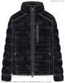 | M0428WT2667 | F9000 | BLACK | FW | MAN | JACKET | CN | 100%PL |  |  |  |  |  | 11 | 7 | 12 | 11 | 6 | 6 |  | 53 | € | 219,00 | € | 11.607,00
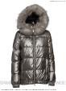 | W0428ST2658 | F1010 | STEEL GREY | FW | WOMAN | JACKET | VN | 100%PL |  |  |  |  |  | 20 | 15 | 5 |  |  |  |  | 40 | € | 259,00 | € | 10.360,00
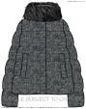 | W0429DTF374 | F1574 | WHITE/BLACK CHEW | FW | WOMAN | JACKET | VN | 100%PL |  |  |  | 7 | 9 |  | 3 | 5 |  |  |  |  | 24 | € | 289,00 | € | 6.936,00
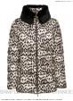 | W0428TTF377 | F5217 | BEIGE ANIMALIER | FW | WOMAN | JACKET | CN | 100%PL | 2 | 4 | 6 |  |  |  |  |  |  |  |  |  | 12 | € | 259,00 | € | 3.108,00
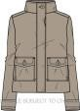 | W7221WT2298 | F5079 | COBBLESTONE BEIGE | SS | WOMAN | JACKET | ID | 100%CO |  | 3 | 6 | 11 | 1 |  |  |  |  |  |  |  | 21 | € | 269,00 | € | 5.649,00
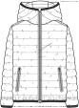 | M84P8FT2421 | F4300 | DARK NAVY | FW | MAN | JACKET | CN | 100%PA |  |  |  |  |  | 1 | 9 | 3 | 6 | 5 | 1 |  | 25 | € | 199,00 | € | 4.975,00
 | W0415GT2662 | F8277 | VINTAGE POWDER | FW | WOMAN | JACKET | CN | 100%PL | 3 | 5 | 8 | 8 |  |  |  |  |  |  |  |  | 24 | € | 249,00 | € | 5.976,00
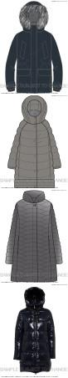
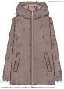

 | W8221ET2410 | F8234 | MISTY LILAC | SS | WOMAN | JACKET | VN | 100%PA | 1 | 5 | 5 | 6 | 4 | 1 |  |  |  |  |  |  | 22 | € | 199,00 | € | 4.378,00
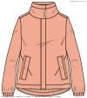 | W8220NT2415 | F7164 | BRIGHT SALMON | SS | WOMAN | JACKET | CN | 100%PL |  | 2 | 5 | 6 | 4 |  |  |  |  |  |  |  | 17 | € | 189,00 | € | 3.213,00
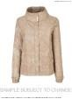 | W8220NTF253 | F5156 | PEPPER BEIGE/LT TAN | SS | WOMAN | JACKET | CN | 100%PL |  | 2 | 5 | 6 | 4 |  |  |  |  |  |  |  | 17 | € | 189,00 | € | 3.213,00
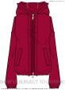 | W8221ST2446 | F7162 | CRIMSON RED | SS | WOMAN | JACKET | CN | 100%PL |  | 7 |  | 1 | 11 | 11 | 1 |  |  |  |  |  | 31 | € | 179,00 | € | 5.549,00
 | M84P0GT0351 | F4300 | DARK NAVY | FW | MAN | JACKET | CN | 100%PL |  |  |  |  |  |  |  | 10 | 6 |  | 1 | 1 | 18 | € | 169,00 | € | 3.042,00
 | M84P0GT0351 | F9000 | BLACK | FW | MAN | JACKET | CN | 100%PL |  |  |  |  |  |  | 10 |  | 8 | 2 |  |  | 20 | € | 169,00 | € | 3.380,00
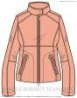 | W8220CT2414 | F7164 | BRIGHT SALMON | SS | WOMAN | JACKET | ID | 100%PL |  | 1 | 3 | 4 | 2 |  |  |  |  |  |  |  | 10 | € | 159,00 | € | 1.590,00
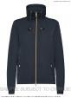 | W0220XT2600 | F4386 | BLUE NIGHTS | SS | WOMAN | JACKET | CN | 100%PL |  | 1 |  |  |  | 5 |  | 1 | 5 |  |  |  | 12 | € | 169,00 | € | 2.028,00
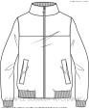 | M84P0CT0351 | F9000 | BLACK | FW | MAN | JACKET | CN | 100%PL |  |  |  |  |  | 4 | 10 | 11 | 9 |  |  |  | 34 | € | 149,00 | € | 5.066,00
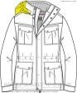 | M84P0DT0351 | F9000 | BLACK | FW | MAN | JACKET | CN | 100%PL |  |  |  |  |  | 2 | 3 | 5 | 2 |  |  |  | 12 | € | 229,00 | € | 2.748,00
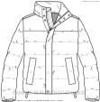 | M84P8CT2422 | F1069 | TITANIUM | FW | MAN | JACKET | ID | 100%PA |  |  |  |  |  | 2 | 4 | 4 | 2 | 1 |  | 3 | 16 | € | 199,00 | € | 3.184,00
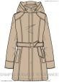 | W8221HT2464 | F5152 | PEPPER BEIGE | SS | WOMAN | JACKET | VN | 100%PA |  |  | 1 |  |  |  |  |  |  |  |  |  | 1 | € | 219,00 | € | 219,00
